**Noah’s Ark CLC Newsletter**

**December 2019**

 Newsletter

Toddler Parents! Can you believe it’s already December?! Please make sure to check your child’s extra clothes bin to make sure they have enough warm clothes available! Also, please make sure to label your child’s jackets in order to avoid confusion. Don’t forget, share day is **Friday,** so please make sure to bring in a toy relating to the theme of the week so your child can participate!

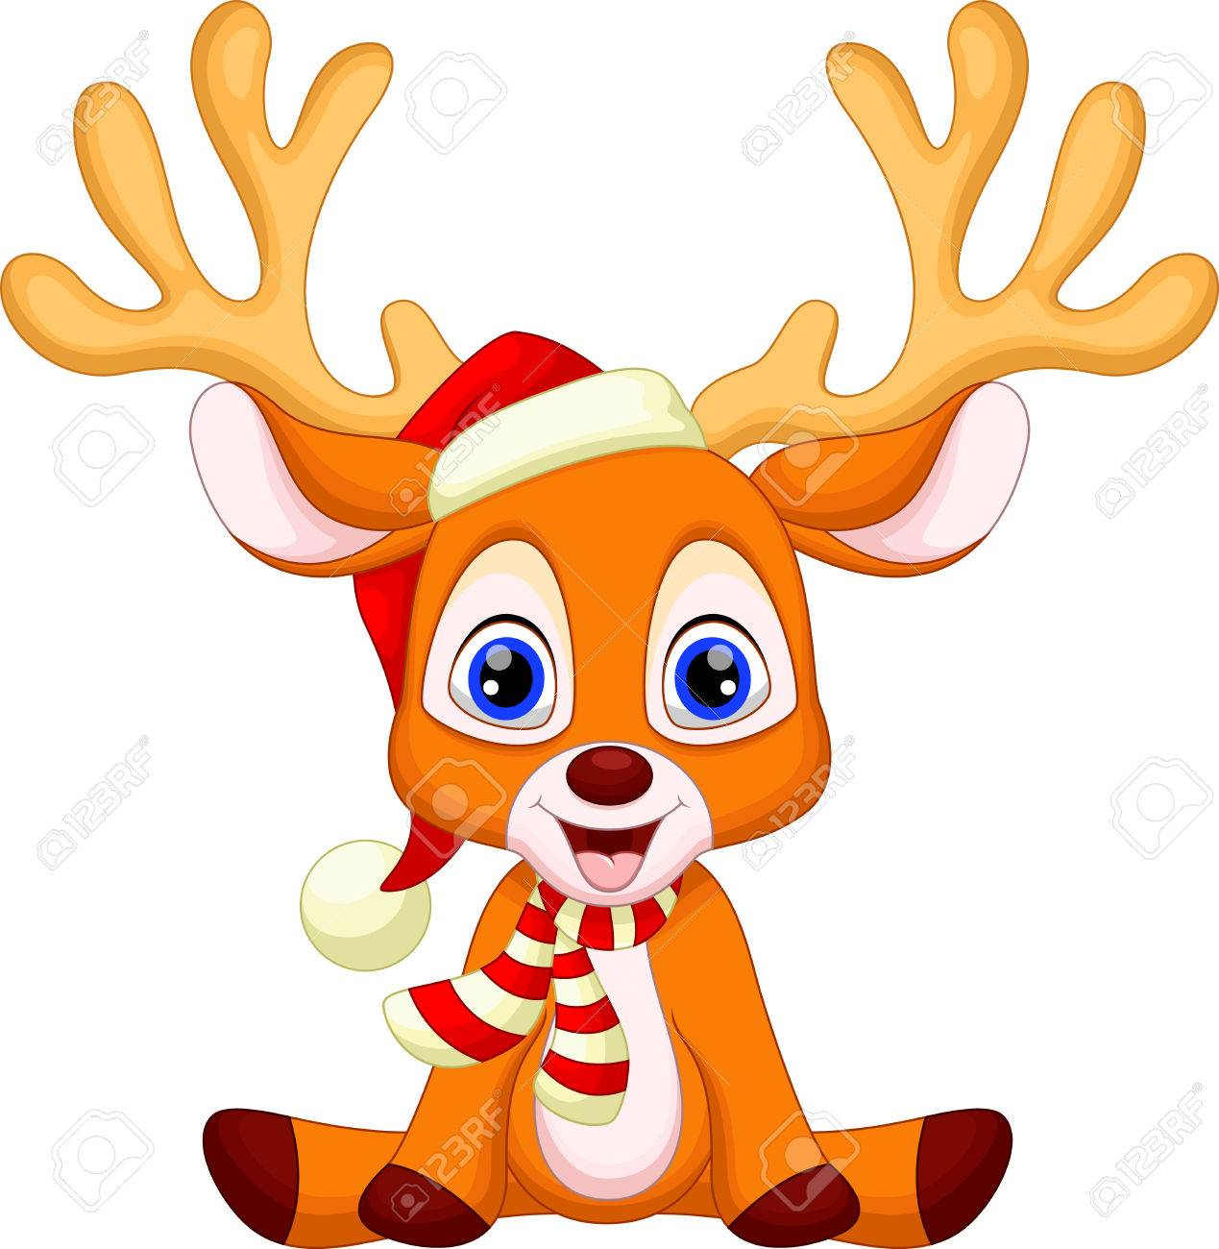

We can’t wait to celebrate the holidays and the New Year with our infants! This will be the first of many celebrations at Noah’s Ark we hope! We have already put up our decorations in order to get the kids in spirit! We are really looking forward having all the kids taking their pictures with Santa!

C:\Users\Noah's Ark\AppData\Local\Microsoft\Windows\Temporary Internet Files\Content.IE5\YZ79PWMN\MC900092679[1].wmf

C:\Users\Noah's Ark\AppData\Local\Microsoft\Windows\Temporary Internet Files\Content.IE5\YZ79PWMN\MC900092679[1].wmf

This month, our pre-school class will be focusing on getting on Santa’s good list, as well as winter activities! Please make sure your child has enough warm clothes in their extra clothes bin. We have a lot of fun themes for the kids this month, and we all looking forward to our annual party!



# Pre-school Room

# Pre-k Room

You better watch out! Our pre-school class has a huge surprise for our Christmas party, they’re practicing from now! You’re all in for a surprise! Our kids are getting ready for Christmas, but will also be learning about different holidays around the world.

# Toddler Room

# Infant Room

**School will close on Tuesday December 24th at 1:00 Pm And will be closed from Wednesday December 25th**

**To Friday December 27th**

**And New Year’s we will close at 1:ooPM on Tuesday 12/31 and will be closed from Wednesday January 1st to Friday January 3rd**

**School will be back in session 1/6/20**

**Joseph Reyes –**December 9th, 2016

**Erik Sanchez**-December 20th, 2014

**Hugo Switzer**-December 27th, 2017



#### December Birthday’s

* **Library –Tuesday December 3rd at 9:30am**
* **Christmas Party –Friday December 20th from 3:30pm-5:30pm**
* **Pajama Day – Friday December 13th all day**
* **Teddy Bear workshop-Friday December 13th starting at 3:30PM**

**Week 1: Science**

**Week 2: Winter**

**Week 3: Snow/Snowmen (toddlers)**

**Holidays around the world (preschool and Pre-k)**

**Week 4: Christmas**

**Week 4: Nutrition**



## Upcoming Events

* PLEASE check your child’s extra clothes bins to make sure they have enough warm clothes in case they need to change.
* Please make sure to check our holiday hours below!
* Please make sure to sign your child in/out every day as this is a licensing requirement. **To our subsidized parents, please sign BOTH pages!
* More information about our Christmas party and other events will be posted later so keep any eye out!
* Please make sure to check your child’s weekly curriculum in each room to stay updated with what they are doing throughout the week!
* Tuition is due every Monday for the week. Please make sure your tuition is paid in full amount!



## Holiday Hours of Operation

# Reminder’s to Parents

# Monthly Themes; December

Noah’s Ark CLC Newsletter Page 2