# Image result for october *Newsletter*

Noah’s Ark CLC newsletter

October 2020

[Grab your reader’s attention with a great quote from the document or use this space to emphasize a key point. To place this text box anywhere on the page, just drag it.]

**Hours of operation**

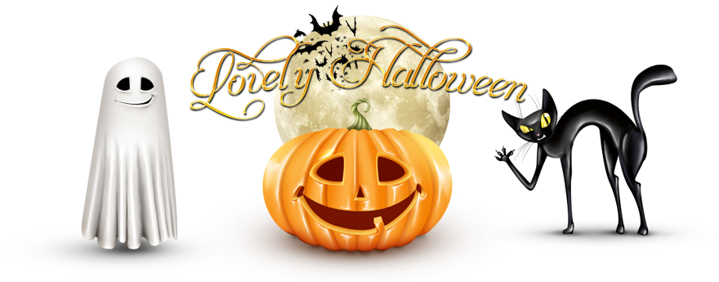

Thank you to all our parents who have been so understanding. Please take a look at our Spooktacular Halloween themed October Menu and the cheat sheet provided! We would love to hear feedback about the menu and anything at all as we are constantly striving to be the best!

**8-4pm**

We are happy to announce we are extending our hours, just a little! We are truly trying our best to try and extend more in the near future**. For now our hours as of October 5th will be 8-4pm**. Staff will be staying until 4:30pm daily to disinfect and deep clean each classroom. We are so thankful for all our parents who have been so understanding and for our hard working staff!

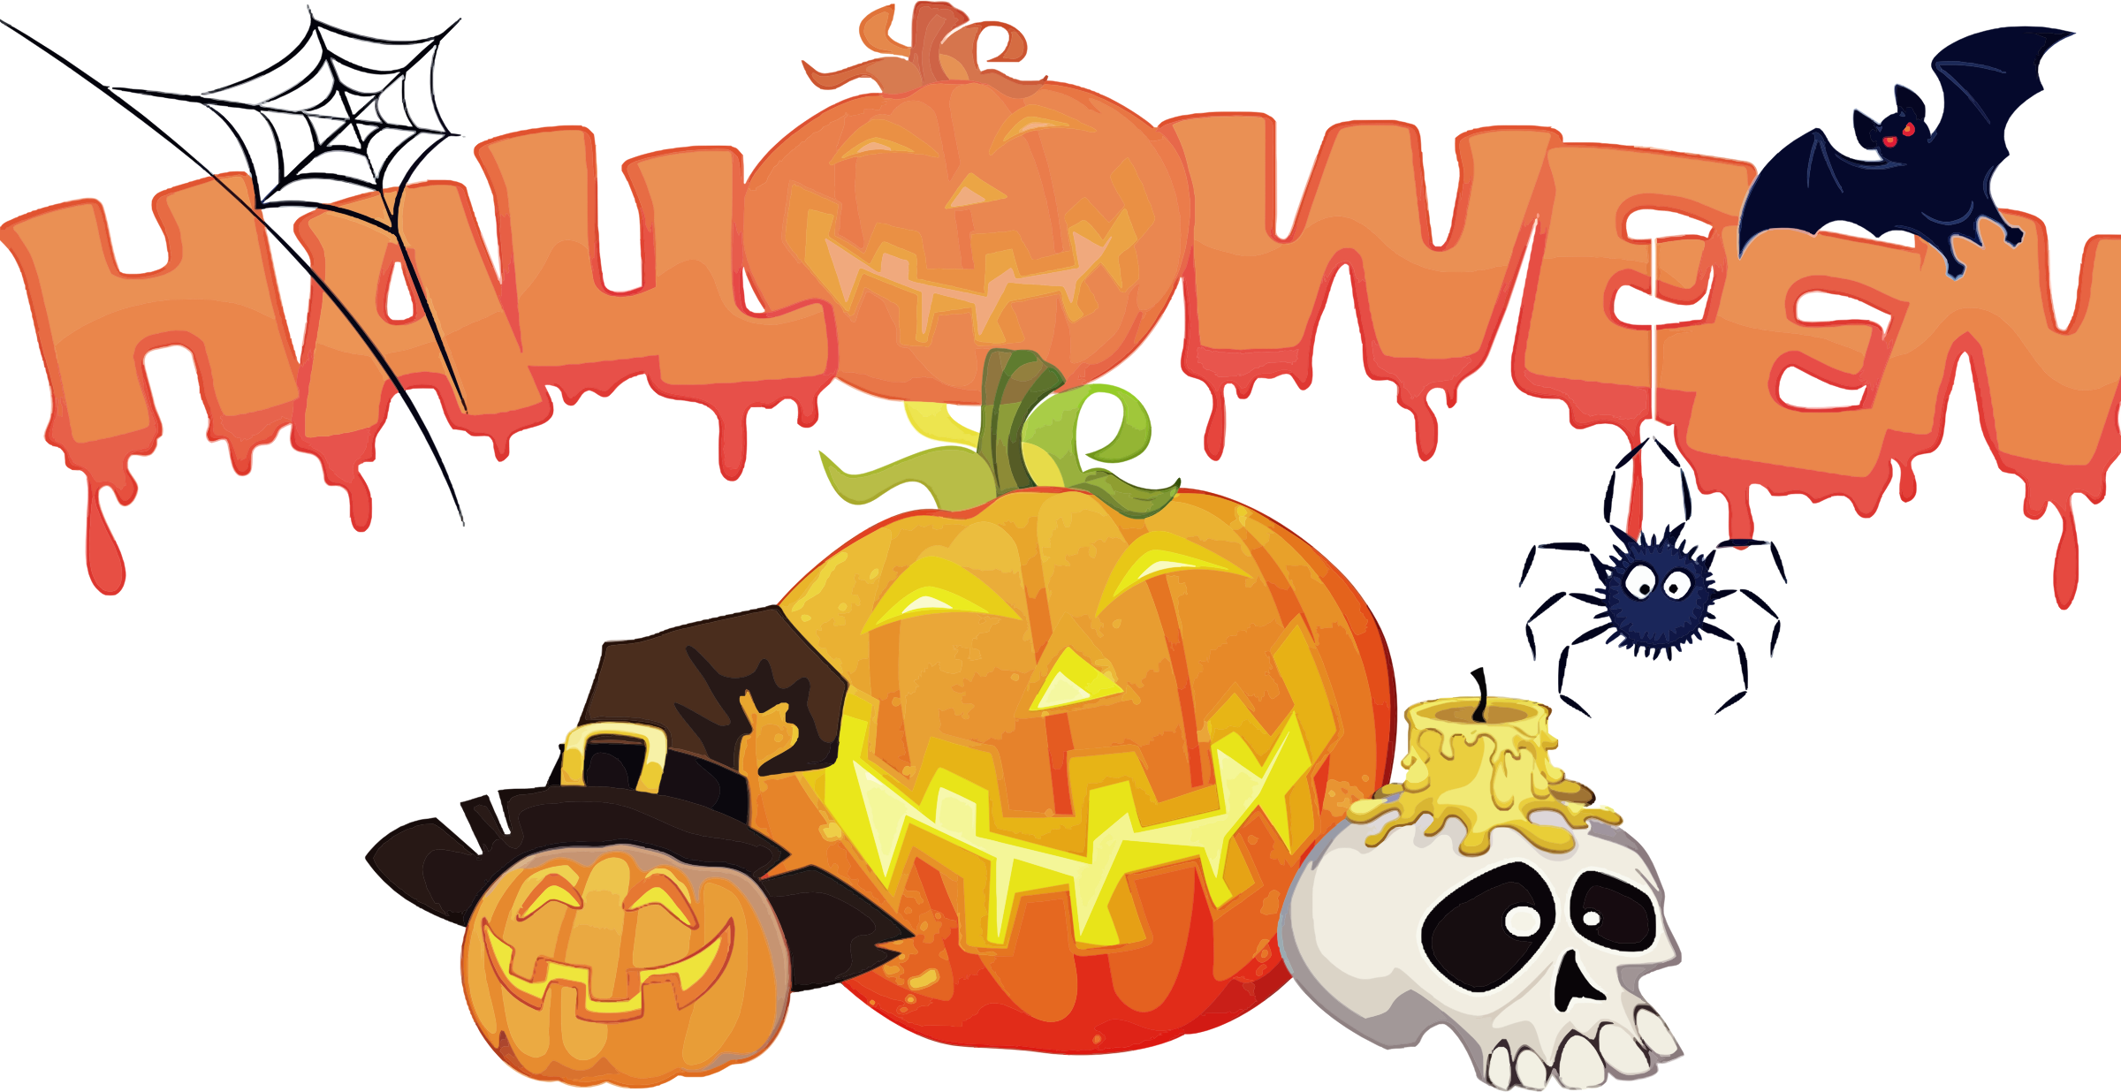

**Halloween Update-**

We all know Halloween was bound to look a little different this year. At Noah’s Ark, we are still going to try our best to make the best of it! We will NOT be having a Halloween party this year unfortunately, but we will still be celebrating! We have a whole themed week at the end of the month with fun ideas and on Friday, October 30th, we will have a fun Halloween Hunt and games and special treats! As for costumes, if you would like to send your child in a costume- it must be something they can put on/take off by themselves. Nothing with extra pieces (crowns, capes, swords, etc). We recommend having them dress in a fun themed shirt instead. Thank you for your cooperation!

**Also- we will be closed Monday October 12th, 2020 for Columbus Day. School will resume session Tuesday October 13th, 2020.**

# Reminders to Parents!

Week 1- Artic Animals

Week 2- Fall

Week 3- Fruits and Vegetables

Week 4- Halloween



# Updates

# Monthly Themes