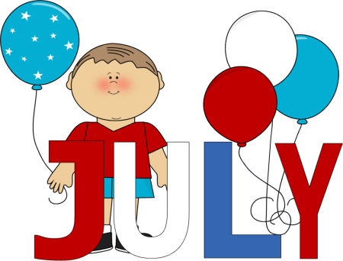
Menu

 | Monday | Tuesday | Wednesday | Thursday | Friday
Breakfast | Cereal  Fruit  Milk | Scrambled eggs  Toast  Milk | Cereal  Fruit  Milk | Whole wheat toast with butter and jam  Milk | Cereal  Fruit  Milk
AM Snacks | Yogurt parfait  Water | Pretzels  Cheese  Water | Animal crackers  Apples  Water | Graham Crackers  Fruit  Water | Fruit Smoothie  Water
Lunch  WEEK 1 | BBQ chicken sandwich  Veggies  Milk | English muffin Cheese pizza  Veggies  Milk | Fish sticks  Rice  Fruit  Milk | Spaghetti with Meatballs  Fruit  Milk | 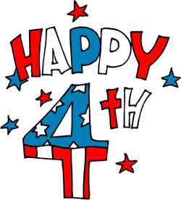
WEEK 2 | Chicken nuggets  Rice  Fruit  Milk | Bubble up enchilada  Fruit  Milk | Chicken fried rice  Fruit  Milk | Turkey meatball  Stroganoff  Fruit  Milk | Broccoli mac and cheese  Chicken nuggets Milk
WEEK 3 | Chicken chow main  With veggies  Milk | Rice  Chicken nuggets  Fruit  Milk | English muffin Cheese pizza  Veggies  Milk | Beans and cheese quesadilla  Veggies  Milk | Octopus pasta  Fruit  Milk
WEEK 4 | Grilled cheese sandwich  Cherry tomatoes  Milk | Spaghetti with Meatballs  Fruit  Milk | Fish sticks  Rice  Green beans  Milk | Turkey and cheese roll up  Fruit  Milk | One pot pizza bake  Veggies  Milk
PM Snacks | Raisins and crackers  Water | Fruit and crackers  Water | Cheese and Crackers  Water | Apples and Peanut Butter  Water | Trail Mix  Water
*PM SNACK MAY VARIES DUE TO SPECIAL PROJECTS IN EACH CLASSROOM, PLEASE SEE LESSON PLAN (SPECIAL PROJECTS ARE MADE IN THE AFTERNOON) Breakfast: Consists of milk, fruit, eggs, bread or bread alternative Lunch: Consists of all five of the following: Milk, vegetable/fruit, bread or alternative, meat of meat alternative
Snacks: Consist the following, juice/water, vegetables/ fruit, crackers, cheese, yogurt /For children with allergies parent will provide the alternative

