Noah’s Ark CLC Newsletter

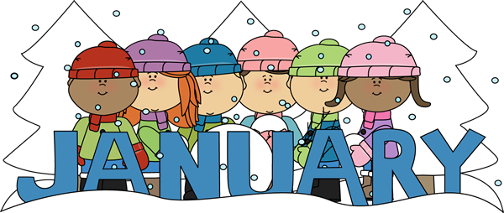January 2020



2020 seems like it will be filled with some super fun activities for the children! Ms. Karol as always has some awesome activities planned and we cannot wait to see what she has in store for the rest of the month.



2020 is finally here! Where has the time gone? Parents, please make sure you check our weekly curriculum to see what activities your child’s class is doing for the week. Ms. Shantell and Ms. Sylvia have lots of exciting activities planned for the month of January.

# Pre-school Room

Parents! Please make sure to check your children’s folders for artwork and homework at least once a week. Also, we have a lot of fun activities planned for this month so make sure to keep an eye out on the weekly curriculums! We hope you all had an amazing holiday/vacation; we can’t wait to start the New Year off right!

Also, we have a lot of fun activities planned for this month so!

# Infant Room

It’s officially January 2020. We are so excited to welcome the New Year with all of our amazing kids and families! We can’t wait to see what the New Year has in store! It looks like 2020 is off to an amazing start! We are so proud of all the developments our children seem to be accomplishing!





# Pre-k Room

# Toddler Room

January Newsletter

**Xander Manica –January 11th ,2016**

**Maisie Harden-January 12th , 2017**

**Beau Bytheway-January 13th,2016**

**Presley Romero-January 27th ,2017**

**Dylan Lopez-January 31st ,2018**



**UPCOMING EVENTS**

1. **January -1st -3rd Holiday School Closed**
2. **Martin Luther King Day – January 20th Closed**



#### January Birthday’s!

# Monthly Themes; January

Week 1- Superheroes

Week 2- Shapes

Week 3- Sesame Street

Week 4- Puppets

Week 5-Disney

## Upcoming Events

* Please make sure to sign your child in/out every day as this is a licensing requirement. It is also a means of communication between parents/teachers. **To our subsidized parents, please sign BOTH pages!
* **Share day- is FRIDAY!** During the rest of the week, we encourage parents to make sure all other toys don’t make it with your children to school.
* Please let the office know of any changes in your personal information such as address, phone #, emergency contact, or pick up contacts.
* **Weather-** Now that the weather is becoming colder it is important to make sure all your children have a set of extra clothes that is appropriate for the weather. Please also make sure to label all items to avoid any confusion
* **Tuition**- Please make sure your tuition is paid each Monday for the week.
* **Sick Policy**- With cold season coming, If your child is or as been sick in the last 24 hours, we ask you keep your child at home in order to help us minimize the germs going around this year.

our child will need the following supplies this year:

1. 3 spiral notebooks
2. 1 box of pencils
3. erasers
4. rulers
5. compass
6. lunch box

# Reminder’s to the Parents

Monday

Today we are learning about dinosaurs.

Tuesday

Today we are learning about pets.

Wednesday

Today we are learning about the solar system.

Thursday

Today we are going on a field trip to the zoo.

Friday

Today we have a special guest from the fire department to tell us about fire safety.

Noah’s Ark CLC Newsletter Page 2