# http://www.clipartkid.com/images/39/september-clip-art-free-http-www-mycutegraphics-com-graphics-month-femYuB-clipart.pngNewsletter

**Upcoming Events**

# Reminders to Parents

**School Closed- Monday**

**September 6th, 2021**

**Spirit Day-Western Day September 3rd ,2021**

**First Day of Fall- September 22nd, 2019**

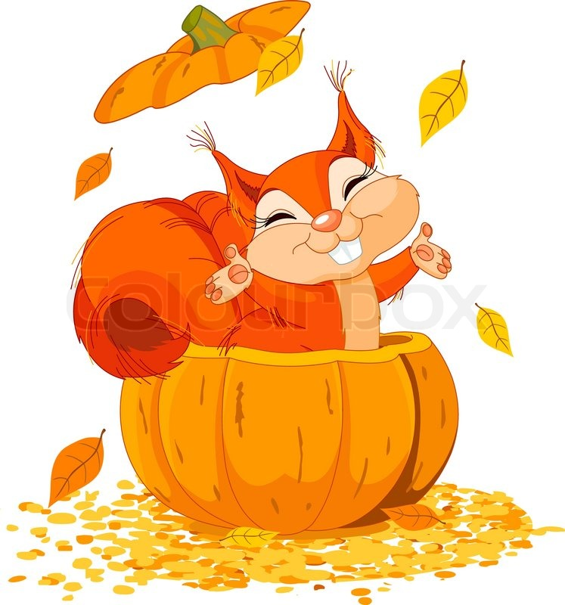

* **Masks- Drop off/pick up -parents/guardians must continue to wear a mask, please!**
* Please notify office immediately and stay home if your child has any symptoms of COVID-19, has been in close contact of someone who has tested positive, or if any family members in the household have had any symptoms of COVID-19.
* **With the new transition happening this** month-please feel free to contact the office should you have any concerns, thoughts, questions at any time! We welcome and encourage open parent dialogue and would love to hear your thoughts! Your children’s safety and well being are always our top concern!

We are so grateful for the continued support by our amazing families who have been patient with us as we navigate.

Thank you all again for your cooperation and understanding.

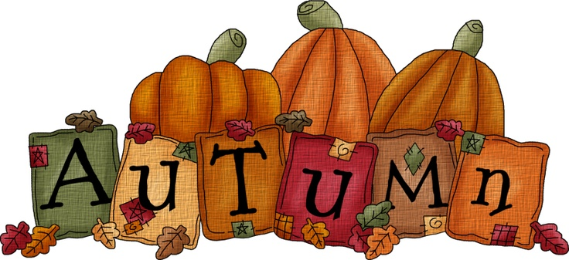

**Week 1:** Transportation

**Week 2:** Space

**Week 3**: Colors

**Week 4:** Forest / Forest Animals

**ek 1:**

## Monthly Themes

# Updates

Noah’s Ark CLC newsletter

September 2021