Noah’s Ark
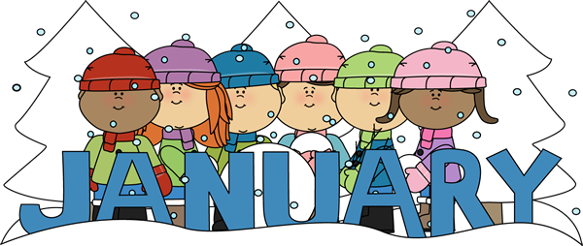
Menu
 | Monday | Tuesday | Wednesday | Thursday | Friday
Breakfast | Cereal  Fruit  Milk | Scrambled eggs, toast , fruit  Milk | Pancakes  Fruit  Milk | Oatmeal  Fruit  Milk | Cereal  Fruit  Milk
AM Snacks | Cranberries  crackers  Juice | Ritz crackers  Cheese | Animal crackers  Apples  Juice | Yogurt parfait  Water | Oranges crackers  Juice
Lunch  WEEK 1 | Cheese Pizza  Fruit  Milk | Turkey roll up  Fruit  Milk
WEEK 2 | Turkey casserole  Green beans  Milk | Bean and cheese  Quesadilla  Corn  Milk | Chicken fried rice  Fruit  Milk | Macaroni and cheese  Chicken nuggets  Veggies  Milk | Chicken noodle soup  fruit  Milk
WEEK 3 | Cheese Pizza  Fruit  Milk | Teriyaki meatballs rice, green beans  Milk | Bubble up enchilada  Fruit  Milk | Bean and cheese quesadilla  Corn  Milk | Wild rice cream of chicken soup  Fruit  Milk
WEEK 4 |  | Octopus spaghetti  Green beans  Milk | Rice  Chicken nuggets  Veggies  Milk | One pot pasta pizza  Fruit  Milk | Vegetable soup  Dinner roll  Milk
PM Snacks | Bananas  Crackers  Juice / water | Trail mix  Juice / water | String cheese  Crackers  Juice /water | Crackers  Juice / water | Teachers choice  Juice /water
*PM SNACK MAY VARIES DUE TO SPECIAL PROJECTS IN EACH CLASSROOM, PLEASE SEE LESSON PLAN (SPECIAL PROJECTS ARE MADE IN THE AFTERNOON) Breakfast: Consists of milk, fruit, eggs, bread or bread alternative Lunch: Consists of all five of the following: Milk, vegetable/fruit, bread or alternative, meat of meat alternative Snacks: Consist the following, juice/water, vegetables/ fruit, crackers, cheese, yogurt /For children with allergies parent will provide the alternative

